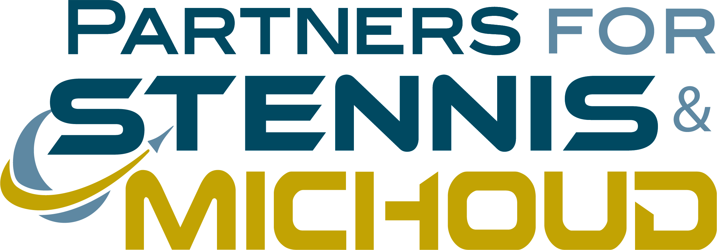

We are contacting you today to invite you to be part of an exciting new event on Saturday, November 11, 2023, in Historic Downtown Bay St. Louis:
STENNIS DAY IN THE BAY
This event, hosted by the Events Committee of Bay St. Louis and Partners for Stennis & Michoud, will celebrate NASA and our Stennis tenants, county, and region’s contribution to our nation’s space efforts for the last 62 years.
Stennis Day in the Bay will run from 12noon – 5pm on the grounds surrounding the Historic Hancock County Courthouse on Main Street. This event will give children of all ages and their families the opportunity to meet face to face with people who work at Stennis from NASA as well as many of their forty federal, state, academic, private, and technology-based tenants. Together they have 5,000-plus employees at high average salaries, and if counted as a single workforce, Stennis Space Center is one of the Top 10 largest businesses in the State of Mississippi.
Anyone with a product or service related to technical education, STEM programs, or space are invited to participate by reserving a booth. Sponsorships are also available for companies to consider. On Friday evening from 5-7pm at the Hancock Chamber Business and Community Center, we will host a VIP reception for visiting dignitaries and event sponsors, which will include local, state, and federal elected officials.
We are inviting the entire county to be part of the celebration. Local restaurants will feature special space named drinks and menu items and merchants will decorate their stores and offer special space related products and promotions to welcome visitors during this event. Features of the event include a “Space Themed” BUD N BURGER Competition, interactive exhibits and displays for adults and children, and a 90th Birthday Celebration for Apollo 13 Astronaut, Fred Haise.
Most importantly, the Stennis Day event will give children the information they need to consider careers in science, technical, engineering and math to grow the workforce for Stennis and Michoud right here at home. With your help and participation in this event, we can make this happen.
Please find attached the details on how you can be a part of this historic event, and if you can, we hope you will consider supporting it as a sponsor. Registration is online at http://partnersforstennis.org.
Sincerely,

Al Watkins Janice Guido
601-530-3447 228-304-0636
al.e.watkns.nasa@gmail.com jguidobaylife@gmail.com

Partners for Stennis & Michoud / 300 South Second Street – Bay St. Louis, MS 39520 / www.partnersforstennis.org / 228-467-9048

